Introduction to Python

https://docs.google.com/document/d/1XFSdjtOEW65I_bVUJqIv_W8rr32r5fv9sJUmCuzQ0fw/edit?tab=t.0

1. Given string my_string = ‘Hello Python!’, Reverse the string using slicing, print ’!’ using indexing

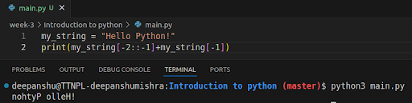

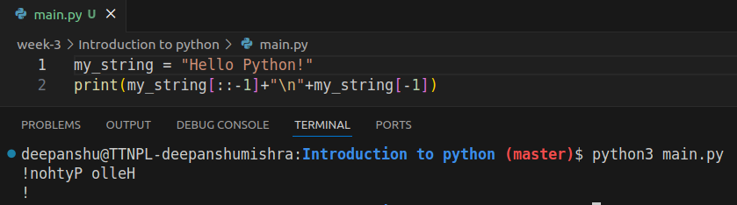

2. Use slicing to get word “frain” from “information”.

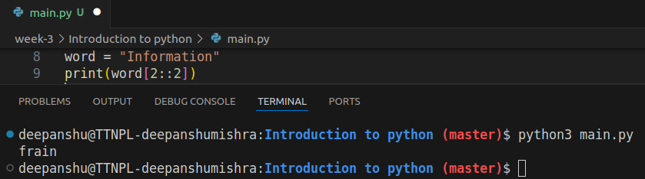

3. Using examples explain string.format and f-strings

Basically f-strings are a more readable and less complex way for formatting strings in python.

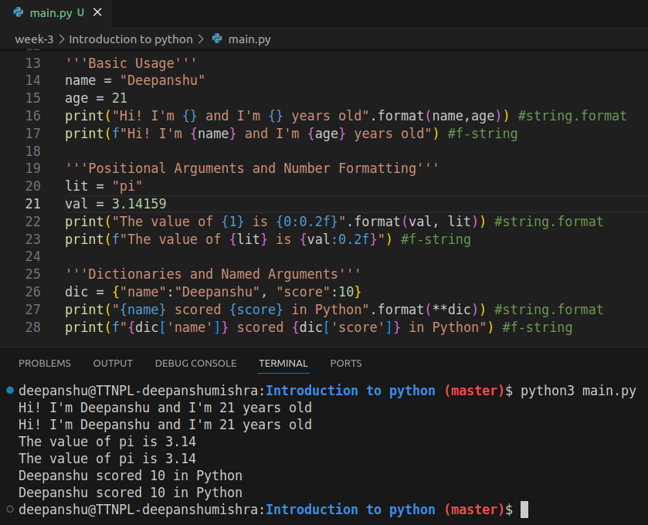

Using f-strings full expressions can be evaluated too

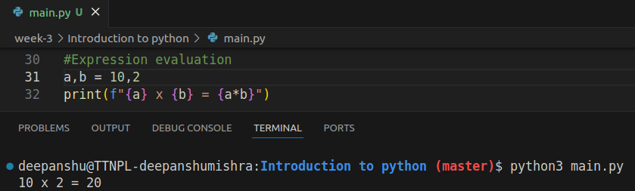

4. Can we sort a dictionary? Why or why not?

Dictionary is a data structure that is used for fast retrieval of data based on a hash function on a key of a key value pair as python dictionaries are basically hash maps and there’s no built in “sort” function for the dictionaries. There is inherently no order of these key value pairs (other than the inserted order since python 3.7+) but we can get either the keys or values from a dictionary and use the sorted function to store the new values in a new data structure like an ordered set or a list

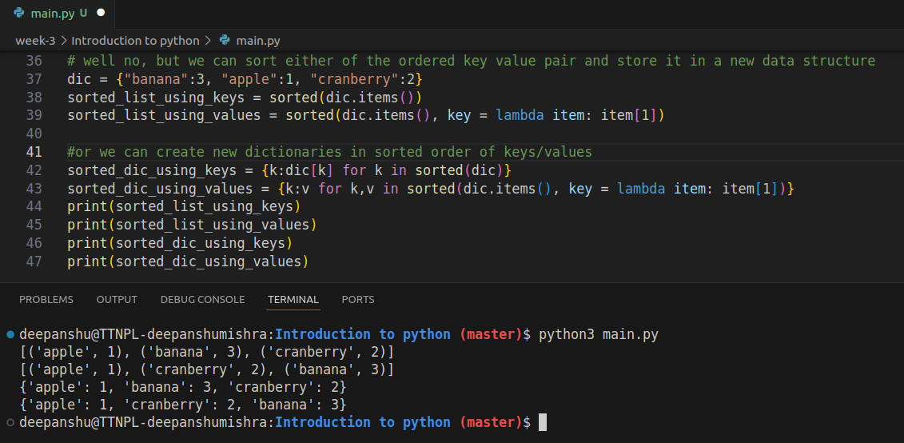

5. Using keys and indexing, grab the 'hello' from the following dictionaries:

● d = {'simple_key':'hello'}

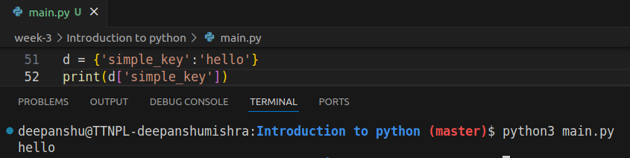

● d = {'k1':{'k2':'hello'}}

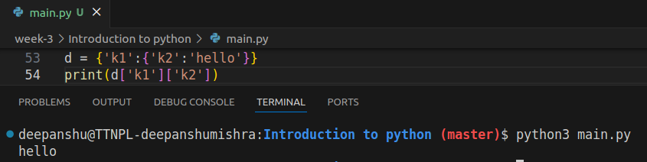

● d = {'k1':[{'nest_key':['this is deep',['hello']]}]}

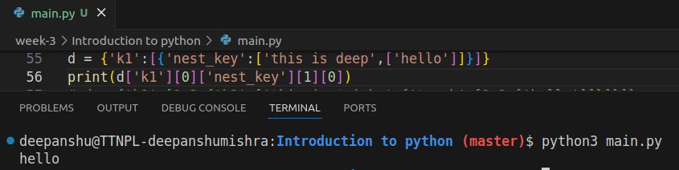

● d = {'k1':[1,2,{'k2':['this is tricky',{'tough':[1,2,['hello']]}]}]}

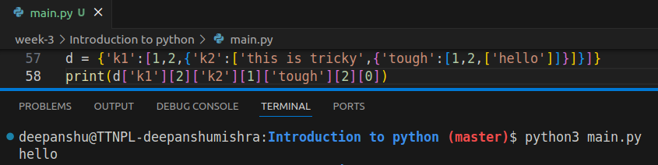

6. Reassign 'hello' in this nested list to say 'goodbye' instead:

list3 = [1,2,[3,4,'hello']]

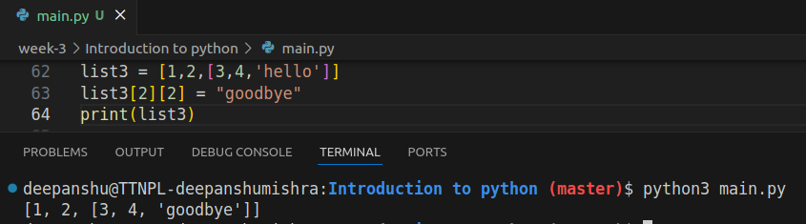

7. From the given list list5 create a set

list5 = [1,2,2,33,4,4,11,22,3,3,2]

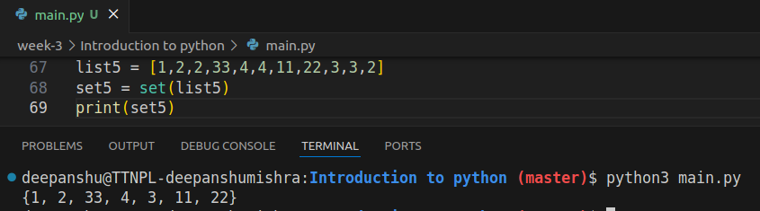

8, In string information count the total number of i.

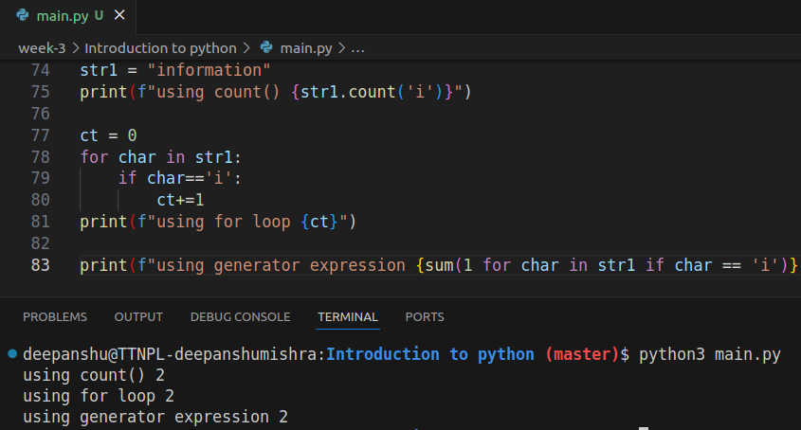

BOOTCAMP PORTAL QUESTIONS

Q1) Write a Python script to test if a number is prime or not? - The Script name: primes.py - Add a functions is_prime() which return boolean True or False - Program should accept a number from console

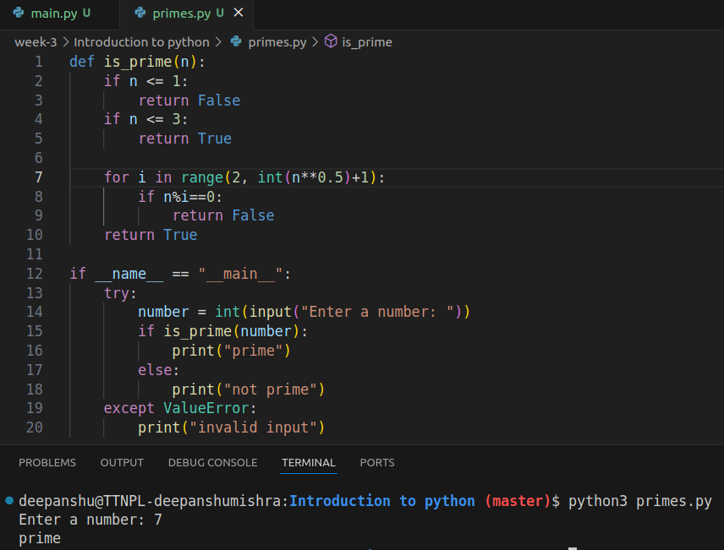

Q2) Write a code to print binary, octal or hexa-deciaml presentation of a number. Do not use any thrid party library.

